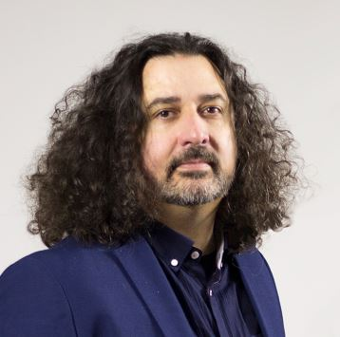
Julian Jahanpour

Actor & Musician

Date of birth July 4th 1973
Nationality British
Address Barcelona
contact https://www.julianjahanpour.com/contact

TRAINING
THEATRE COLLEGE, Henley on Thames
LONDON ACADEMY OF MUSIC AND DANCE

FILM & TV

BEAUTIFUL SOULS film, dir. Tom Schreiber (drunk rocker)
EN HAUTE MER mini series - Dir. Denis Rabaglia, ALVA FILMS (Konstantin)
LOGIC x HITRECORD: DO WHAT YOU LOVE, Music Video Short, HitRecord
BAND TOGETHER WITH LOGIC, TV Special, HitRecord
THE UNSTRUMENT (Carmelo), Libre Albedrio Films
OPENING SCHOOL (waiter), Bausan Films

THEATRE
TITLE OF SHOW, Jocular Theatre
ALICE IN WONDERLAND, Escapade Theatre
FAUST FOOD, Tremayne Theatre co.
6 CHARACTERS IN SEARCH OF AN AUTHOR, 12x12 Theatre co.
THE SNAPPING TURTLE’S LAMENT, Jocular theatre
THE TRIAL, 12x12 Theatre co.
GHETTO, 12x12 Theatre co.
A MIDUMMER NIGHT’S DREAM, 12x12 Theatre co.
BRAVE NEW WORLD, 12x12 Theatre co.
VOLPONE, 12x12 Theatre co.
SCHOOL DAYS, Open Theatre, Eina d’Escola
JAMES AND THE GIANT PEACH, Apollo Theatre, Oxford
JOSEPH AND THE AMAZING TECHNICOLOUR DREAMCOAT, The Hexagon, Reading
PADDINGTON BEAR’S MAGICAL MUSICAL, The Hexagon, Reading

LANGUAGES
ENGLISH (native), SPANISH, CATALAN

SKILLS
actor, piano, comedy

